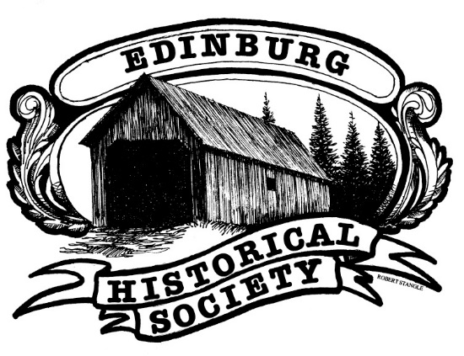
Edinburg Historical Society
PO Box 801
Northville, NY 12134
http://EdinburgHistoricalSociety.org

2023

Please sign me up for the Saturday July 8th Historic Edinburg Day Festival. Please use enclosed envelope.

Name __________________________________________________________ Phone ____________________

Address __________________________________________________________________________________

Email address ________________________________________________

I will require a ____ X ____ space. Do you have any special needs? _________________________________

I will be selling ___________________________________________________________________________

I will be setting up a tent. ( )Yes ( )No

Edinburg Historical Society
PO Box 801
Northville, NY 12134
http://EdinburgHistoricalSociety.org

2023

Please sign me up for the Saturday September 23rd Edinburg Fall Festival. Please use enclosed envelope.

Name _______________________________________________________________ Phone _______________

Address __________________________________________________________________________________________

Email address ________________________________________________

I will require a ____ X ____ space. Do you have any special needs? __________________________________

I will be selling _____________________________________________________________________________

I will be setting up a tent. ( )Yes ( )No

